UMAKANTA NAYAK  (HADOOP-SPARK-ETL CONSULTANT/DEVELOPER)  Mob.9337900849  PLOT NO:1182,OLD TOWN,  KEDARLANE  BHUBANESWAR,ODISHA  Email: nayak9umakanta@gmail.com | 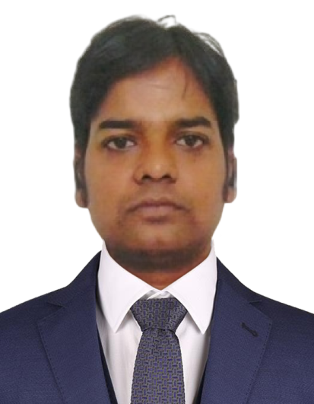
Professional Experience:
Overall 9+ Years of experience in IT Industry and 4+Years of experience as Hadoop/Spark/Pyspark Developer using Big data Technologies like Hadoop Ecosystem,2.5 years in ETL Developer Spark Ecosystems ,Azure Data bricks and 5+ experience in .Net(C#)and 4 years experince in python,Pyspark
Big Data Ecosystems: Hadoop, MapReduce, HDFS,,AWS ,Azure Databricks,DATAFACTORY,Linux
- Languages: Python
- Databases: Oracle 10g,Sql Server 2012 , mongoDB 5.0 , Teradata 12.0,Cosmos DB
- Framework: spark,pyspark,Azure Data bricks,
- Ingestion Tools:Apache NIFI, Azure Data factory

Company Name:Publicis Sapient
Payroll:Ushankk Enterprises pvt ltd
Duration: (21th sep 2023-5th dec-2023
Client: UHG
Language:Python,Pyspark
Role :Azure Developer
Role_Performed:
- Importing data from Oracle using Azure Data factory and Pyspark Notebook into Azure Data Lake Gen2
- Scheduling jobs in Adf on every weekend at 8Am

Description:This project design for developing and enhancement of the Data Warehouse related to sales,marketing.The entire data is present in oracle. Migration doing from oracle to Data lake using Databricks and adf .

Company Name:TCS
Payroll: Netconnect Pvt Ltd
Duration: (8th Feb 2022-17th Feb 23)
Language:Python,Pyspark
PROJECT NAME:Elementum
Client:Unilever
Role :Azure Developer
Roles Performed:
- Retrieving the business requirement feed from client to get a clear idea about the requirements.
- Importing data from SAP HANA using Azure Data factory into Azure Data Lake.
- Performing business logic in databricks on imported data from sap hana as per requirements provided by client.
- Scheduling jobs in data bricks on both full load and delta logic
- Involved to resolving defects which are raised by testing team
Description:
The application deals with the day to day sales, marketing and transport data of Unilever. This project mainly involves the development and enhancement of the Data Warehouse related to sales, marketing and transport data Of Unilever. The entire sales, marketing and transport data is located in the Sap Hana,
Migration doing from Sap Hana to Azure data lake. For that copied data we write business logic as per requirements for analysis.

Company Name:Crushaders Tech Solution(2019 -2022)
Project Title: RM Extract (31st July 2019 to 2nd Feb 2022)
Client: SpringHill
Domain: Hotel
Role: Hadoop Consultant
Environment: Spark,Scala,aws,s3, Intellij, Jenkins, Sql Server, Oozie and Git
Description: RM Extract project is a replica of a mainframe project, the project includes data repository which includes hotel data of 2000 hotel banches all over the world, to build the revenuegeneration and analysis. Project is generating multiple financial and rooms transaction report usingmultiple spark job and mainframe job.
We have various Spark jobs which are scheduled to run by oozie in different time frame. The jobstakes multiple .json file as input and produces output in Parquet file format. The final output file gets stored in S3 bucket.

Roles and Responsibility :
- Create, validate and maintain scripts to load data using Sqoop manually.
- Worked in dual role as Project Manager and TechLead. Resolved Technical issues Raised by business users.
- Proactively communicated project status, issues and risks to internal stakeholders and top management
- Conducted regular project status/quality meetings and reports. Kept management and key stakeholders well informed on a weekly basis on project progress, status and/or concerns for each assignment.
- Assessed business implications for each project phase and monitored progress to meet deadlines, standards and cost targets.
- Responsible to set up weekly status meetings with the team and report the monthly status to program manager.
- Articulated project goals and scope, translated business needs into technical terms, prepared detailed work breakdown structures (WBS) and instilled shared accountability for achieving project milestones.
- Responsible for leading the complete technical life cycle of project completion starting from 10-Day estimate to Testing to Deployment to project closure
- Responsible to coordinate with conflicting project requirements with other stakeholders while defining the project scope
- Create Oozie workflows and coordinators to automate Sqoop jobs weekly and monthly.
Net Developer(C#) 2013-2019
Company Name:Shiftu Technology Pvt Ltd
Client:Ringcompany (from 2013 to 2019)
Team size:10
Technology: Asp.net 2.0/3.0 ,Ajax,Webservices, WCF
Duration: 6 years
Client :ringcompany.com(USA)
Company: ShiftuTechnologies Pvt Ltd
URL: https://ringcompany.com
Project Details: Ring Company designs specially crafted class rings, school ring, corporate ring, company rings of latest designs of your own choice.Its basically
for customize ring design one can do design himselfby the help of the step which is implemented in this project.It contains two uses
1)Public Site
2)Admin Site
Public Site:-Here one can design here with the help of this site and url is:https://ringcompany.com/ .Once complete he can check out his/her order
He can show his design in feature with the help of this.
Admin Site:Everything is control by Admin if anyone can need changes at the public site admin can change at the mean time. Here he can check the how many order still now.Anyway here some module bellow
• Dashboard
• Order in progress
• Shipped Order or Cancel
• Dealer Profile
• Design List
• User List
• ErrorLog
• Distributor
DashBoard:what feature is added till now it is given just like
Improved sorting and searching on screens listing designs and orders.
When a ring is being designed, the shank selection screens have been modified. Now the customer can choose between SCHOOL MASCOT (if any) or SCHOOL SYMBOL (if any) or OTHERS.
Order in progress:It contains new order without csr.You can check out or process by clicking the given order no.
Shipped Order or Cancel: How many order is shipped or cancel till now admin can check it out.
Dealer Profile: Here only dealer profile is given bellow.
User List: It is a one type of searching page what type of user is till now .
ErrorLog: If any error is happening then it is write here or you can see details
NON-IT
COMPANY: NISSI BBSR(2005-2013)
ROLE: Office Assistance

Education
2005, MCA Kiims,Utkal University,Odisha
2002, Graduation, Jaidev College
1998, 12th ,Devrai college
1996,10th Unit-1 Boys High School

